BA.NET - Private Cloud Office

Modern Team Collaboration

Managed Nextcloud + Onlyoffice

(c) BA.net/office - Jan 2020

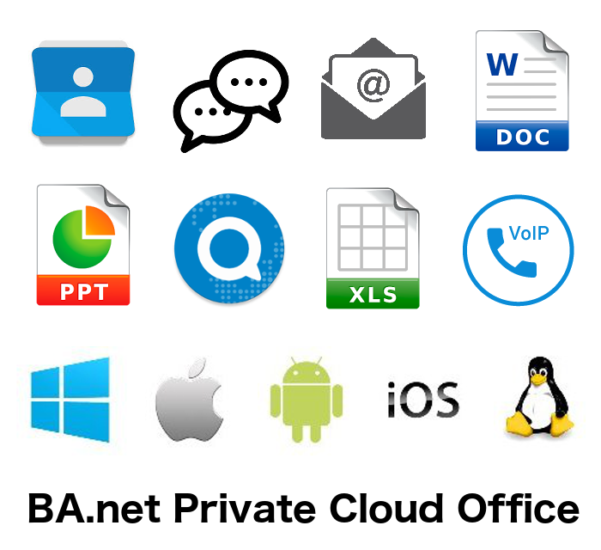

BA.net - Private Cloud Office - Modern Team Collaboration
(c) ba.net iphone@ba.net

Chapter 3, 4 and 5 and portions of other chapters part of Linux HowTo´s and Linux Guides copyright Linux Documentation Project LDP.

The optional FlashBoot Software Appliance contains software provided by GNU/Linux, CentOS and other providers covered by the GNU General Public License.

BA.NET - Private Cloud Office 1
Modern Team Collaboration 1
Managed Nextcloud + Onlyoffice 1
1 BA.net Private Cloud Office 5
Always-On-Support 6
Connected Business 6
Open Source Software (OSS) 7
2 How Async Communications can help your team 12
2.1 Longer Streaks of Uninterrupted Work 13
2.2 Easier Decision Making 13
2.3 Allowing More Thoughtful Responses 13
2.4 Stored Conversations That Can Be Referenced 14
2.5 The Need to Be Online (Or at Your Desk) Is Now Gone 14
2.6 Overcoming Time Zone Issues 14
2.7 Conclusion 15
3 10 Must-Haves for Successful Team Collaboration 16
3.1 Take your team to the top 16
3.2 Why is team collaboration necessary? 16
3.3 What does successful collaboration look like? 16
3.4 Elements of effective team collaboration & best practices 17
3.5 How to foster team collaboration best practices 20
4 A Guide To Distributed Teams 22
5 Productivity Suites Are Eating Enterprise Software 34
6 Private Cloud Office Alternative to the public cloud 39
6.1 Open Source software (OSS) 39
6.2 Enter Vendor Lock-In, Privacy, Compliance And The Hybrid Cloud Solution 42
Great hybrid, local-first software should have seven key properties. 42
7 The Open-Source, Private Cloud Alternatives to Dropbox, Slack, Office 365 45
8 What microsoft won’t tell you about office 365 subscriptions 51
9 BeyondCorp: How Google Dropped VPNs for Remote Employee Access 53
10 How to Build a Remote Team: Resources and Advice From Remote Companies 58
A lot of companies are already working remotely from the office 59
Advice from remote companies 60
GitLab 60
Doist 61
Teamweek 62
Services to help you build a remote team 64
Start slowly 64

BA.net Private Cloud Office

- 100% Compatible with Microsoft Office
- Edit Documents, Spreadsheets and Presentations
- Team Collaboration on any Device, any Place
- Replace Slack, Gsuite, Office 365
- No per User Charges
- Dedicated Business Server
- Cloud or Self-Hosted

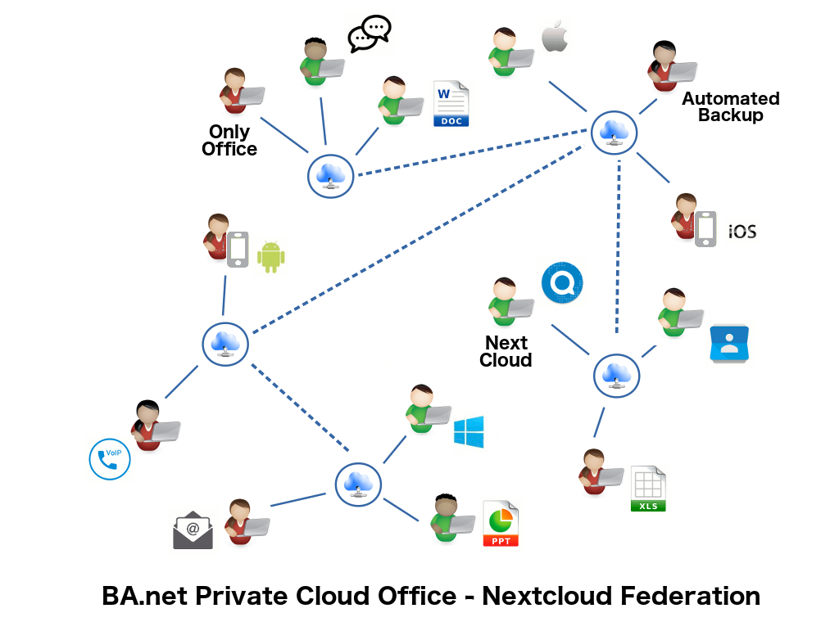
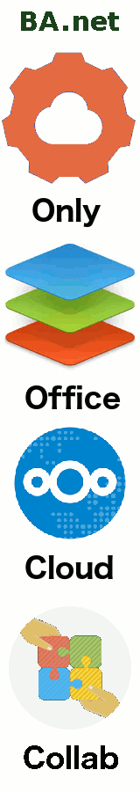
BA.net Office Self-Hosted - On-Premise
- Local Onlyoffice with Nextcloud Integration
- Running on your own hardware
- Can work Off-Line
- Can Sync with Cloud Federation
- Can be backed-up automatically
- Turnkey Software Appliance
- Easy Pendrive Boot
- No Storage Limit
- 1 year Software Updates
- 1 year Support

Gain peace of mind with a dedicated IT team and the flexibility of the private cloud.

Increase your Productivity

With modern collaboration tools. Asynchronous team communications. Join the future of work with better tools for distributed and remote work.

Always-On-Support

With our customer support executives offering round-the-clock support, we make sure that all your Office-related issues are resolved quickly.

Connected Business
We create a complete business solution by integrating your Office applications , Email, Storage, VoIP without any restrictions.

Open Source Software (OSS)

Freedom, flexibility, low cost, no vendor lock-in, no jumping through monopoly license hoops, enables byod, local software, hybrid cloud.
Enterprises gain access to a modern browser-based document editor fully compatible with Microsoft Office formats, integrated in a powerful file exchange and communication platform. The product allows employees to collaborate across organizational boundaries and on the go while controling data access, compliance and security.

With over 5 million users, Onlyoffice is a proven innovator in the online office business, first to market with a full HTML5 based online document editor. Built on cutting-edge technology, it offers advanced features including change tracking, version history and rights management. With a self-hosted solution, enterprises can be confident data never leaves the control sphere of their IT department.

Regain control of your data and communications while getting the benefits of open source. BA.net offers the flexibility of cloud, self-hosted and hybrid solutions.

Why do you need a project collaboration software ?

Collaboration is the way for a team to come together by sharing knowledge, experience and skills. A project collaboration software should offer a set of tools that enable team members to get projects done, quickly find information they need and above all communicate and work together to achieve common business goals. The core elements of a project collaboration software are email, document editing and sharing, group calendar, team collaboration and real-time collaboration (Video Conference, Chat).

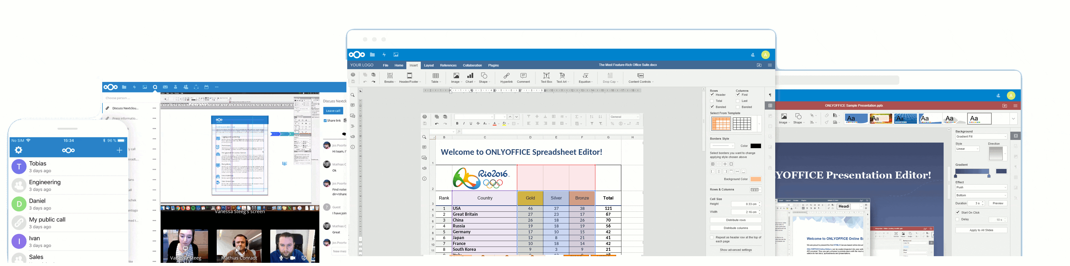

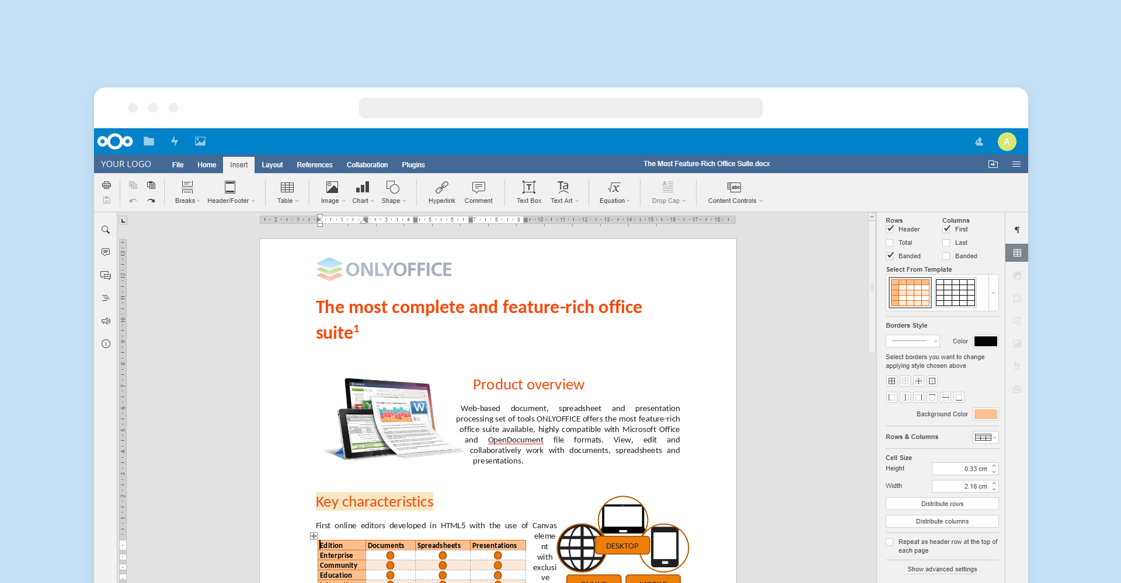

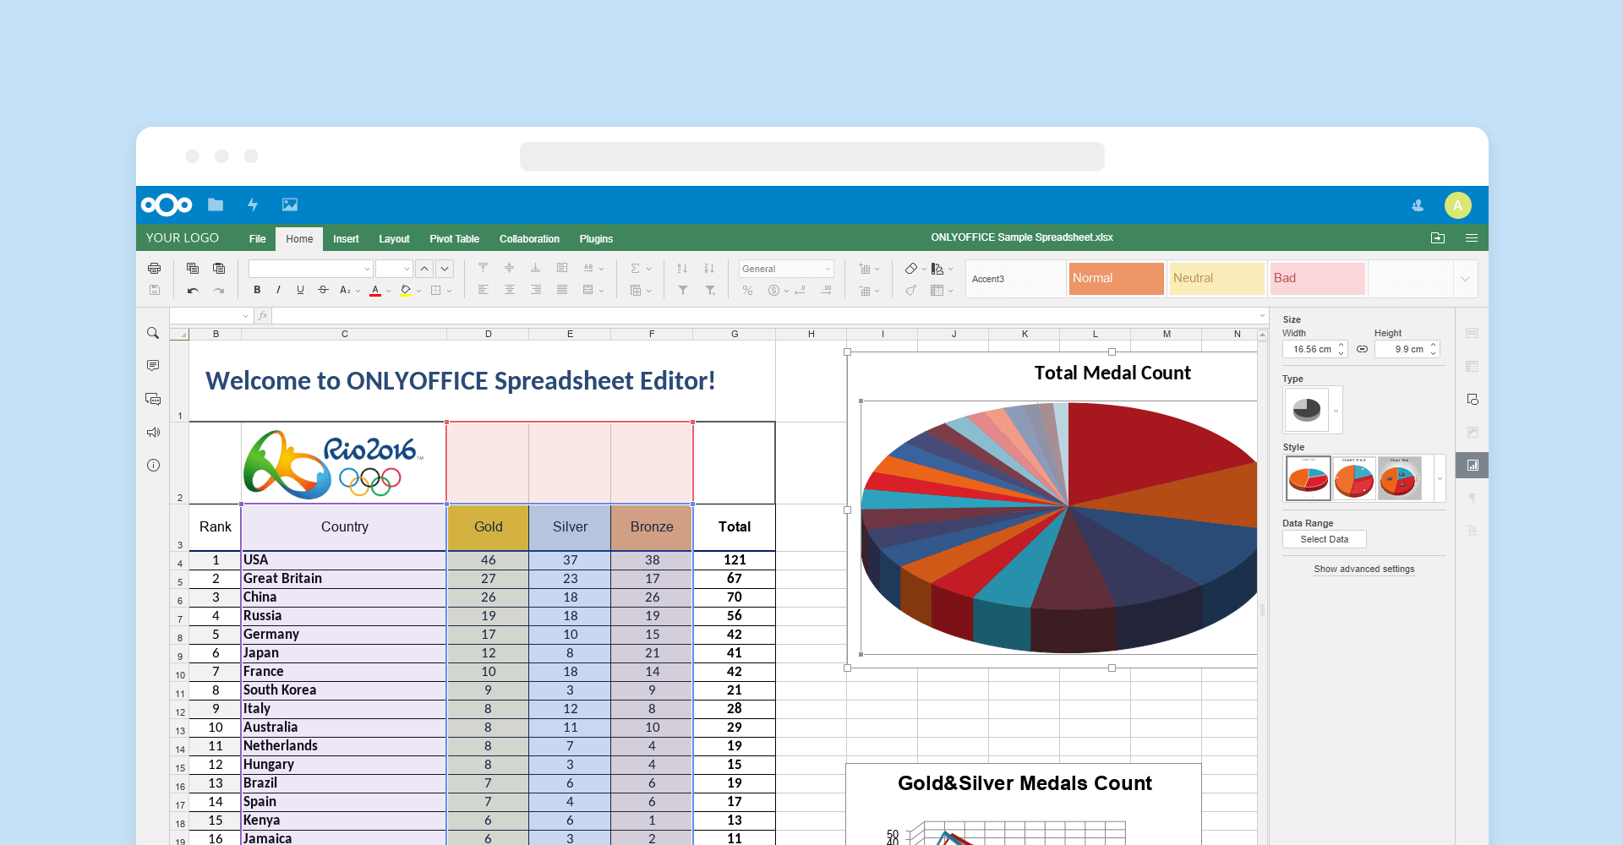

Why use BA.net Private Cloud Office

Gain peace of mind with a dedicated IT team and the flexibility of the private cloud.
Protect your Business Data

Take control of your information. Make your data Private.

Cut Costs Replacing O365 or Gapps

100% compatible with Microsoft Office. Edit Documents, Spreadsheets and Presentations. Collaborate in Real Time. Save 70%

Works with all popular file formats: DOC, DOCX, ODT, RTF, TXT, PDF, HTML, EPUB, XPS, DjVu, XLS, XLSX, ODS, CSV, PPT, PPTX, ODP.

Always-On-Support

With our customer support executives offering round-the-clock support, we make sure that all your Office-related issues are resolved quickly.
Connected Business

We create a complete business solution by integrating your Office applications , Email, Storage, VoIP without any restrictions.
Key Benefits

Advanced control including remote wipe and next generation secure watermarking. Document Change tracking, version history and rights management.

Data access from Office, Remote, Desktop, Mobile. Integrate your remote locations and teams with chat, audio and video conferencing.

Personal Support

Dedicated account manager. Custom solutions. No per user charges. Easy flat server pricing.

Self-Hosted

Local Onlyoffice with Nextcloud Integration. Can Sync with Cloud Federation. Automated Backups. Turnkey Software Appliance. Easy Pendrive Boot. Running on your own hardware. Unlimited storage.

Built to Scale

Designed for uptime and reliability. Redundant servers. Deployable on 20 geographically distributed datacenters.

Dedicated Team

We do Cloud Servers all day, everyday. We can also help you with mixed environments. Windows, OSX, Linux, Cisco. Our team has 20 Years of ISP and MSP experience.

Open Source Software (OSS)

Freedom, flexibility, low cost, no vendor lock-in, no jumping through monopoly license hoops, enables byod, local software, hybrid cloud.

How Async Communications can help your team

At BA.net, we believe that distributed work is the future of work, and that’s fundamentally the main reason we launched our product to help teams run async. Distributed work is deeply linked to being asynchronous —usually just async. The concept is not easy to grasp at first for most people. Its official definition is: “[said] of two or more objects (or events) not existing or happening at the same time”. In shorter words, asynchronous means that things do not happen in real-time.
By going async, you free up both ends in the communication process from having to be synced up. And the best about it is that you can still communicate effectively even when you’re not responding immediately.

This style of communication is becoming more and more popular due to the rise of remote work within companies around the world. Distributed & remote work is a trend that’s here to stay as companies of all sizes are starting to realize the great benefits it brings to their organizations.

And, surprise! Even if you are on a full on-site team, you are already doing async communication partly —unknowingly— by using email, discussing new functionality through a JIRA ticket, or by answering to a Slack question when you allocate the time for it —and not as soon as you receive the question.

So here are a few points where async communication will help and benefit your team:

Longer Streaks of Uninterrupted Work

By going async you can help your team achieve uninterrupted work: it lets your team members stay focused on their work. No strict timed replies. Respond as you can. Your team members are never really “bothering” each other, but rather communicating when both parties are available to do so and work on the topic.

Easier Decision Making

Never depend on fixed calendar meetings. No need to have to organize everybody together in a room, at a specific time, to just make a decision. No meeting room found? Let’s postpone the decision making for 3 more days, at an inconvenient time, because that was the best slot we found, the other slot was just impossible to work out. All of this is a hassle, but still widely accepted.

Allowing More Thoughtful Responses

We all take part in work conversations, and it is very important to be able to say the right things, with the right tone, at the right time. When we’re confronted with a question within a topic and are always expected to reply right away, not always the best answer comes out immediately after the question is made. This is where async communication comes in handy: it allows you to think more and help you compose a better and more suitable answer within the conversation.

Stored Conversations That Can Be Referenced

Today there are great tools out there that allow you to store and reference async conversations you have with your team. Indeed, here at BA.net, we built the ability to store all your video updates, with an unlimited history, so any person from a team can refer back to one of the messages later in time, which is especially great when you’re wanting to see how something ended up working out, by seeing progress of it through the related stored videos of the task.

The Need to Be Online (Or at Your Desk) Is Now Gone

When you have an async communication process in your team, there’s no more need to be “online” ❇️ with a green badge, or by your desk, in order to be reachable and be part of a meaningful work conversation. You can just start a conversation around a topic, no matter where the other team members are in that moment. This will liberate your team and will sweeten up your team culture by helping to drop the sense of urgency for most topics that get usually addressed in a team.

Overcoming Time Zone Issues

Time zones issues are a topic of its own, and one of the main challenges surrounding distributed teamwork. Luckily, this problem can be reasonably solved by implementing async communication. Since in distributed teams one team member can still be sleeping, already another team member can start to add to a conversation, and later in the day, the other team member can catch up and contribute his/her points to the discussion.

Conclusion

Async communication helps your team members increase their productivity and effectiveness, by allowing them to become more flexible at work. Most of the processes within your team don’t have to happen in real-time in order to be successful and reach their main goal.

Your team doesn't need to be distributed or fully remote in order to start leveraging the benefits from async communication, as your team is probably already doing async communication of some sort without really noticing it, by using email, responding to a Slack message only when you get the time for it, after a doctor's appointment or after picking up your kids from school.

10 Must-Haves for Successful Team Collaboration

Take your team to the top

It is every project manager’s dream to have a team that not only smashes their goals, but creates effective collaboration in the workplace while doing it. While not an impossible feat, it’s not a given either. Here’s what your team will need for successful team collaboration.

Why is team collaboration necessary?

Team collaboration is nothing new, and there’s more to it than just making sure everyone gets along with each other. It’s about finding new ways of working as a team, fostering an innovative culture, and coming up with new team collaboration ideas to achieve goals and objectives, and acquiring better solutions.

With the world more connected than ever, and a bustling freelancing / entrepreneurship / DIY work culture on the rise, knowing how to develop lasting working relationships has never been more important. It is also necessary for business growth and development, as well as keeping ahead of your competitors.

When it comes to project management, the benefit of team collaboration is not only delivering the project with ease and success, but it’s also about achieving a sense of accomplishment with group, and gaining new experiences and insights.

What does successful collaboration look like?

Successful team collaboration is going to look a little different depending on your team’s goals and objectives. Generally speaking, however, if said goals and objectives were met in an enthused and unified fashion, then that’s something to be pretty happy about.

Here’s what you’re team’s going to need for effective collaboration in the workplace.

Elements of effective team collaboration & best practices

1. Great communication

Effective communication is what separates successful teams to the ones who fail. Having clear instructions from the get go and throughout the project delivery, asking questions instead of making assumptions, and actively listening to the members of your team can not only create a culture of camaraderie, but it also provides transparency in your responsibilities and expectations. It can also reduce stress levels and tensions that can sometimes arise when working closely with others.

2. Engaged employees

An employee who is detached from the work, their peers, and the project’s goal is not going to want to collaborate. To prevent a disengaged team, ensure that every member knows their purpose, and that their contribution towards the project is valued. Remember that an engaged team is also a happy and focused one, too.

3. The right leaders

A successful team is not without its expert leaders. Being tasked the responsibility of guiding a team towards their target is not an easy thing to do, and requires a fusion of technical, personal, and organizational skills. Your job as a project manager is to ensure a kind of harmony that not only drives the team to meet the their objectives within the set timeframe and criteria, but also to accommodate to the different individuals in the team, and foster a collaborative working environment.

4. Skill of compromise

Having a group of people with different ambitions and egos will mean that everyone won’t always see eye to eye. But knowing how to compromise — a core element of team collaboration skills — is what will get everyone to agree on a solution, and keep the work flowing smoothly. Not only does it illustrate consideration for your fellow team members, but it also demonstrates your willingness to be cooperative, and set differences aside for the sake of the team and its success.

5. Conflict management

Sometimes when you group together a bunch of people to work on a project, there can be unfortunate instances where they may not get along (which is a big no-no for effective team collaboration). Although as a project manager it is ultimately your job to resolve any conflict that may arise within the team, it is a great skill for team members to be able to manage and resolve any issues themselves. This type of skill displays remarkable team collaboration, and can also strengthen the bond between team members.

6. Reliability

Reliability builds trust, and without it, you don’t really have a team, you just have a bunch of people working together begrudgingly. Being part of a team means having to rely on others to hold up their end of the bargain. The success of a team depends on every members’ efforts and contribution. This is especially the case for teams that have members working remotely.

7. Team player attitude

An absolute must have of team collaboration is, of course, team players. Having a ‘team player attitude’ means committing to your team, and putting the group’s best interest ahead of yours. What needs to be remembered is that, in this context, the effect of a combined effort is greater than individual performance. So if you want your team to reach their goal, everyone has to work together to achieve it.

8. Diversity

Diversity doesn’t just apply to the different skill sets and expertise of the roles required to deliver the project, but also to the personalities of the individuals in the roles. The beauty of working in a team is that it exposes people to different perspectives and experiences, which does wonders for developing relationships. Plus, it’d be a tad ho-hum if you put together a group of people who were exactly like each other — nothing new would be learnt!

Diversity is super for team collaboration!
9. Open dialogue

Creating an open dialogue where feedback goes both ways enhances the skills of your team, and solidifies trust. No one knows the efforts that you go through better than the people who work closely with you every day. Team members exchanging advice and constructive criticisms to each other will only improve performance, and build stronger relationships.

10. A team collaboration tool

The reasons for using team collaboration software are quite straightforward. As a vital element of effective collaboration in the workplace, they offer your team a centralized solution where all the project’s work can be announced, shared, updated, and executed on. Using a tool like Zenkit comes with features that can further heighten team collaboration skills. For example, its integration feature with chat platform apps will make communication between team members easier and more accessible, and its visual scheduling system allows for project transparency, so that everyone is aware of their responsibilities, and how the project is coming along.

How to foster team collaboration best practices

Even if your team are already aware of team collaboration best practices, it’s not enough to just have them, you have to ensure that they are ongoing until the team is no more. Here are a few tips you can try to keep the harmony going.

Make sure everyone knows each other

The very first thing you should do, once the team has come together, is to do some ‘get-to-know-each-other’ activities. Once the project has started, and you feel your team needs a little refresher, you can always set aside time to do team building activities to keep the momentum going. When people know who they’re working with, it creates a more relaxed, and friendlier working environment.

Maximize team member strengths

Knowing the strengths of individual team members not only makes you a great team leader, but can optimize the team’s overall performance. Every member will bring something unique and valuable to the table. For instance, you may have someone who excels at breaking down instructions, or you might have the world’s most organized person on deck. Whatever their talent is, developing it and encouraging them to utilize it will not only boost the group’s efficiency, but is also great for your team members personal development.

Set an example

The best way to encourage team collaboration skills is to showcase your own. As the project manager, your behavior and attitude influences how your team conduct themselves. Be reliable, provide constructive feedback, communicate effectively, listen and compromise with your team, and ensure you are trained and well versed in using whatever team collaboration tool you choose so that you are on hand to offer any guidance or support that is required.

A Guide To Distributed Teams

How thoughtful systems (and lots of emoji) make for happy, efficient teams—whether your desks are distributed across floors, cities, or continents.
Guest Post Katie Womersley, Juan Pablo Buriticá

When we’re both writing, you’ll see this: ■ ▲ All teams past a certain size become distributed, whether across rooms, floors, buildings, cities, or continents. But tech is only starting to explore and invest in remote workplaces, which means that, as an industry, we don’t really know what success looks like.

Ultimately an effective distributed team is an effective team. Evaluate your distributed organization the same way you would if everyone were in the same place. Are you accomplishing your goals and moving forward? Do you have a plan, and do all team members understand it? Do you dedicate most of your working time to your team goals? Are team discussions (and disagreements) constructive? Does everyone feel safe giving and receiving mindful peer feedback in product, engineering, and design spaces?

What makes distributed teams different is intention and advanced planning. Remote teamwork doesn’t happen by accident, but through deliberate systems and practices around communication, coordination, collaboration, organization, operations, and culture. Communication

■ Communication doesn’t just happen on its own. On remote teams, the default state is, instead, miscommunication. But with deliberate and explicit communication channels in place, your teams will be more productive, easier to manage, and better able to grow.

When you’re running a distributed organization, assume that someone missed the email, message, announcement, or meeting. It’s hard to gain context when you don’t see someone day-to-day and when you can’t rely on hallway chatter to spread a message or passively keep people on the same page. It’s your responsibility, therefore, to get your team on the same page: Get used to repeating yourself, and drop the passive-aggressive “as I said last week” and “per my last email.” Research shows that neutral tones come across as negative, and positive tones as neutral. Overcorrect with emoji, GIFs, and explicit communication. Sarcasm and irony are big gambles—our advice is to skip them. Your team should feel like, and be, a safe place to ask any kind of question.

One of the biggest questions distributed teams face is synchronous versus asynchronous communication. Synchronous communication happens in real time: back-and-forth group chats, video calls, and meetings. Asynchronous communication has a lapse between sending the message and receiving the response: recorded video messages, task-tracking software, collaborative documents, forums, and email. Both types of communication are important for healthy distributed teams, and getting the balance right has a massive impact on productivity.

When the real-time exchange of ideas is crucial, choose synchronous communication channels. Combing through an email backlog or discussing strategy on a forum is time-consuming and ultimately ineffective. Synchronous communication bonds teams and is vital for creative ideation. It’s also much easier to spot looming problems and dysfunctions in a synchronous environment because it offers more behavioral data. That being said, don’t let synchronous communication be ad hoc. Get your teams on a cadence so they can block times on their calendars and be present. This is especially important if you’re spread across time zones.

Asynchronous communication, on the other hand, allows people to engage when it best suits them, reducing unnecessary meetings and nonstop chatter. People can get deep work done and take time to formulate responses. Making written communication channels the default makes information distribution clear and reliable. It also means that the direction individuals get from you is consistent. When communication practices are standardized, events like adding new members to the team are less taxing on the group—which sets your team up for fast growth. The same practices that work for adding one member work for many more. Written best practices evolve and scale better than oral tradition.

Healthy distributed teams blend synchronous and asynchronous styles. Because what doesn’t have to be synchronous is better done asynchronously, default to asynchronous communication for nonblocking items and help team members review them on a cadence. Thanks to the internet, written communications are accessible and aren’t subject to the limitations of physical presence, serendipitous encounters by the seltzer machine, or inconvenient taps on the shoulder. When making a decision, ask yourself: Do I truly need a real-time back-and-forth on this? Coordination

■ Crucial to coordinating a team is time, which impacts everything from communication to collaboration, culture to hiring. It’s harder for a distributed team to react quickly, but you can mitigate slower reaction times by building predictability everywhere in your organization. Establish a tempo. When the CEO asks, “When does our next iteration start?” you should know the answer. This is the beat that everyone else can predict and build upon.

Maintaining the tempo can become tricky as you build cross-functional units made up of several teams. There will come a point when keeping all teams in sync will have more value to the organization than it will to individual team members. Customized cycles are worth exploring, especially when teams are spread across time zones.

▲ Because Splice is a hybrid organization (some teams are remote, others are co-located), my distributed engineering teams collaborate with design, product management, and business development teams co-located in NYC. Instead of building a globally distributed team, I made the decision early on to hire within a constrained range of time zones, aligning with U.S. Eastern through U.S. Pacific time.

● At Buffer, our total time-zone spread is 15 hours, with team members in Europe, the U.S., Asia, and Australia. Within product engineering teams, we try to keep the time-zone spread to eight hours or less, depending on how willing team members are to shift their workdays to accommodate meetings. We have synchronous meetings over video to plan and break down large features, and to brainstorm with PMs and designers on upcoming work. We also record all team video calls for those in distant time zones.

The time-zone spread means that Buffer engineers routinely “pass the baton,” where two or more engineers working on one feature hand over work at the end of a European workday to a U.S.-based teammate. (Often in this overlap period, two or three engineers will jump on a call, pair a bit, or screen share, sometimes even link terminal sessions with tmux.) This style of teamwork avoids knowledge silos, keeps morale high, and ensures continuous input from others.

▲ The greater the time-zone spread, the less easy it is for teams to schedule meetings or react in real time. It also increases the likelihood that someone’s lunch (or other meal) will be affected by standups, planning sessions, or retrospectives. And if the spread is large enough, people will inevitably be left out—or be asked to accommodate their life to work. And when you ask team members to adjust their hours, you’re asking for time that belongs to the employee.

● For instance, in the case of working parents, they may be faced with a meeting time that’s either 7 a.m. in Vancouver and 4 p.m. in Croatia, or 9 a.m. in Vancouver and 6 p.m. in Croatia. Consider that 7 a.m. isn’t an easy time for a business meeting when you’re getting little ones to school. On the other hand, 6 p.m. is tough on dinner, bath, and bedtime. On individual teams, a time-zone overlap of at least two hours during “regular” working time is essential. Often, someone still needs to compromise.

▲ In hybrid organizations, like Splice, active management keeps co-located teams from dominating scheduling preferences to the detriment of remote workers. With a wholly distributed company, like Buffer, your organization is time zone–aware and async-friendly by default. While fully distributed teams can more easily transcend time zones than hybrid organizations, predictability is vital across the board.

Collaboration

▲ Distributed teams aren’t better than co-located ones, but they are different. For me, the differences make my job as an engineering executive easier. Being physically constrained means that strategic direction changes need to cross a slightly higher value threshold to be acted upon. I used to see this as a limitation to collaboration, but then I realized that hundreds of OSS projects have been successful with this constraint and chilled out.

Glue work is “whatever it takes to make an organization successful,” including strategy, meetings, project management, design review, mentoring, and coaching. ■ Both of us have worked with our organizations to develop promotion processes that explicitly reward collaborative behaviors like mentorship and glue work. In both Buffer and Splice’s career matrices, we explicitly require a certain standard of mentorship and collaboration to be promoted to the next level. Rewarding collaboration is also an important part of reducing a gender wage gap on your team, as research published in the Harvard Business Review suggests that in collaborative cultures, women disproportionately carry the burden.

● Real-world face time still plays a critical role—it’s impossible and unwise to try to eliminate this entirely. Invest in getting your distributed team together at least every six months. (This can be an entire company, divisions, or even just the teams that work closely together.) Remote whiteboarding is possible, and not as hard as you might think, but there’s no substitute for the camaraderie and serendipity of time spent together in person.

▲ Teams should meet in person as often as possible without making travel a burden. (Six months seems to work well for teams I’ve run.) But for anyone, more than two days together is overwhelming. Curate talks, workshop and coworking time, and social activities. Bring in people from other departments for information-sharing and exposure. Not everyone does well in social activities, so make them optional and don’t judge absences. In-person gatherings should be almost like mini-conferences. Consider forming a committee with interested team members to help plan it.

To pay for in-person meetings, create a recurring line item in your budget and protect it. It’s important that the business understands this operational expense is as critical as paying rent. Be frugal, but not cheap. Use your company resources responsibly, but understand that a five-stop flight will deliver you an exhausted, rather than energized, team member. As your team grows, frequent gatherings may yield diminishing returns. If that happens, reduce their frequency. Aligning onsites with strategic planning periods can also work very well. But it’s more important—and ultimately more effective—to spend time together than to get work done.

● Collaboration is both an art and a science. Observe carefully what works and what doesn’t. No two teams are exactly the same, and team needs change with structure and product life cycle. As a manager looking to promote collaboration, ask yourself: What is most effective right now? Be ready to adjust and to change your mind. Organization

● Brook’s law states that “adding [developers] to a late software project makes it later.” With distributed organizations, it goes into effect even earlier. As teams that work closely together grow, so does the volume of written information they generate. Eventually, information becomes hard to find and knowledge silos develop. Explicit, asynchronous communication puts a strain on collaboration in big groups, too, as every single person provides a detailed comment to every other thoughtful comment, resulting in long-running threads thousands of words long. But organizational structures can counteract these effects.

A focus on small teams anchored the organization’s growth from three to 2,300. The easiest way to get around the scaling law is to keep your teams small. In product engineering, think about the number of engineers working with a single product manager. In a distributed team, three to four engineers to one product manager works very well, whereas more than six or seven becomes actively difficult.

Reduce interdependencies by ensuring that a single team owns a customer-facing outcome (whether an end-user experience or an internal customer) and has the full complement of engineering, design, and product skills they need to successfully deliver that outcome.

Instead of having backend and frontend teams, for example, cross-functional teams allow decisions to be made close to the problem at hand. Most importantly, everyone involved is responsible for how the whole product fits together.

● Resist the temptation, however, to add every function that could in any way affect the experience, or you’ll run into scaling challenges. Rather, embed functions like mobile, product marketing, data, QA, and support by having representatives attend important kickoff meetings, share summaries, and recorded video calls as needed, and help your team understand when they need to seek out specialized input.

However, with a cross-functional approach, domain expertise and standardization is lost. Small product-focused teams risk constantly reinventing the wheel. Pain points that moderately affect every team don’t float to the top of any team’s priority list, even though the organizational gain of solving them is huge.

To counteract this, use working groups organized by function. Depending on needs, these can be informal discussion groups focused on sharing knowledge, connecting people, and advocating for solutions, or they can be more formalized structures with a specific task, like implementing a system of frontend components.

▲ In organizations of more than 30 people, I’ve also had very positive results tasking a single team with the customer-facing outcome of “delivering software.” They are responsible for clearing road-blocks in the delivery pipeline. This doesn’t mean they do everyone’s work, but rather that they support getting other teams’ work out the door. At Splice, this is our production engineering team, comprised of site reliability engineers (SREs), frontend reliability engineers (FREs), quality reliability engineers (QREs), and security. In the past few quarters, they’ve been responsible for stabilizing and reducing cycle time.

● Embrace the overlap between roles. Sharp, territorial boundaries in distributed teams mean that important things fall through the cracks and hard conversations are easily avoided. Encourage your team to develop the necessary experience and expertise to offer constructive feedback on other teammates’ work. Instead of worrying about who is accountable for the design and the code, encourage the messy middle. Both teams will better succeed when helped by the other.

Operations

▲ Effective operations bridge strategy with execution, and help companies learn faster than the market—all before they run out of money.

Equipment and environment are essential components of this: Distributed workplaces can be a cure for the proliferation of open-office colosseums where productivity goes to die. ● The minimum an engineer needs is a laptop, headphones, and decent internet. At Buffer, we reimburse these basics, plus fast home internet (fiber is best) or a coworking space. We give folks new laptops when they join, and replace laptops after three years, or sooner if needed. ▲ Splice also offers a home-office improvement stipend that can be used for peripherals, accessories, or anything that improves your work space, like plants. We ship you a monitor and laptop of your preference, and give you an office-chair stipend.

● When you’re hiring remotely, hire remotely: Have your process mirror how you’ll work. Interview folks over video call, rather than in person. Pay attention to the clarity of written communication during hiring emails and how responsive your candidate is. Do they arrive to the video call on time? Do they send back your take-home on time? If not, are they communicative about needing more time? A candidate who’s hard to connect with during hiring isn’t likely to be a great remote worker.

During interviews, ask about experiences the candidate has had around independent work, initiative, having a growth mindset, and being able to “get on with things” and unblock themselves reasonably well in an imperfect environment with some level of ambiguity. Also ask about times they’ve been frustrated at work. Do those frustrations sound like your team’s day-to-day? These are better predictors of remote success than just asking whether they’ve worked remotely before. ▲ Technical exercises should have clear rubrics that make your process repeatable, and should not only look to evaluate candidates’ technical knowledge or expertise but also whether they are mindful in their communication. Try a code review using Amy Ciavolino’s “Guide to Mindful Communication in Code Reviews” to define your rubrics.

■ However well you hire, your new team member will flounder without clear, organized onboarding. Worse still, new people band together to support each other and answer questions, leading to misinformation and culture fragmentation. Develop detailed 30-, 60-, and 90-day onboarding plans and check in at each 30-day mark. Give new hires buddies who introduce them to your operations and values. This culture scaffolding helps people integrate fully into the team more quickly.

▲ It can be beneficial for your team to adopt a process for distributed decision-making similar to opensource projects such as Rust or Ember. Requests for Comments (RFCs) have become one of my favorite tools for this operational need. They allow everyone to provide input into decisions other teams are making, potentially on behalf of others. And you get a historical record as a bonus. RFCs work best if used as a space for proposals, and cause friction if they are used to seek consensus. Culture

▲ Trying to fulfill utopian expectations for workplaces sets you up to fail. There will always be differences in the team members’ experiences: People in HQ get snacks, but remote folks don’t have to deal with commutes or pants. (But please wear pants!) You can try to level the playing field with good A/V equipment, spaces, headphones, stipends, and meeting etiquette, but the experiences will still be different. And that’s okay.

■ Moreover, not everyone thrives in remote environments. You’ll have to adapt your support mechanisms for people as they transition into this mode of work, and set mutual expectations about how to signal when it’s not working. Extroverted folks can feel lonely, isolated, and disengaged. Anxiety and depression are also more common with remote work, where flexibility can translate into a total loss of structure and routine, and freedom can feel like abandonment.

● You also can’t see how people are doing in a remote team—if they’re tired, stressed, down, or jubilant. To counteract this, we talk about “traffic light” color check-ins a lot. We start and end most meetings with a color check-in. It’s typical to see messages in group chat like, “Hey everyone! I’m signing off for today, feeling :green_heart:” or, “Hey team going off for today feeling yellow.” It’s quick and easy, and it helps remind us that we’re all humans. Knowing if someone is red, yellow, or green gives team members a chance to support each other, and managers a chance to reach out and offer help.

At fully distributed organizations, you need to reinforce your culture constantly or you’ll end up as a network of freelancers rather than a gelled team. If you don’t have stated company values, figure them out—you can’t rely on the office vibe without an office. ▲ If you work in a hybrid organization, the distributed portion of your team will mostly live the company as if it were a TV show, witnessing only meetings they’re invited to or large town hall–type events, piecing together little by little how things work in HQ. Leaders in HQ should get in the habit of working remotely every so often, so they can experience the environment and build empathy for remote work.

● With the various cultures at play in globally distributed teams this is critical work when it comes to inclusivity. For instance, stating collaboration as a value means that it will be easier to help create an environment where everyone takes turns speaking. A global company culture can transcend local norms in cases where they may be in conflict.

Be lavish in your praise of any and all behaviors that are in line with those values, and swift and firm in discouraging behaviors that are not. Praise should be public and far-reaching: People will emulate behavior they see rewarded. In a distributed team, that reward needs to be explicit.

Be aware that remote employees work from home and live at work. Studies show that remote workers work longer hours on average—sometimes, a full extra day per week. As a manager, knowing if people are working is not your main concern. The real issue is knowing if they ever stop. Model healthy boundaries, turn off chat apps, and take your vacation time truly offline. Don’t let your remote team develop an “always-on” norm: It’s easier, and more destructive, than you’d think.

Final considerations

▲ Distributed teams enable me to distribute opportunity: I get to share the experience of building an impactful product with talented folks around the world. I also love working with people from different cultures, places, and lifestyles—it enriches my life. The autonomy and flexibility appeal to me. And I can scale teams much faster, which costs less in the long run. The downside? Not being able to spend more IRL time with the people I work with.

● My favorite thing about remote work is popping my own bubble. I almost never think of my network in a geographic sense: We’re all just people on the internet, trying to make things better. Like Juan, I enjoy being a free agent—having autonomy over my time and my environment. The hardest part is my hobbit-like tendency to not leave my apartment. I now schedule “out-of-home” activities each day to avoid a serious hermit relapse. Oh, and my massive FOMO that all the office workers are hanging out together on patios.

▲ No matter what constraints you choose to lean into or away from, be explicit about them and what the trade-offs mean for your team. As you build a distributed organization, these decisions are yours to make. As your team grows, they’ll live these choices, and hopefully the organization will evolve into something that continues to work better for everyone.

Productivity Suites Are Eating Enterprise Software

As a whole, enterprise apps are typically hard to use. They're rolled out generically company-wide and suffer low adoption rates. While it's not a secret that users dislike enterprise software, it took a decade of using really awesome consumer apps, and a new generation entering the workforce, to help us realize what was wrong.

Millennials make up the largest generation in the U.S. workforce, and what they’ve become accustomed to in their personal lives is slowly becoming part of their expectation at work. Today’s consumer expectations, coupled with millennials' need for productivity and on-demand experiences, are contributing factors that are changing how today’s software companies and IT teams approach the enterprise.

These changes didn’t happen overnight, and many critical enterprise apps are still clunky, outdated and confusing to users. Some, however, like Gmail, Asana, Slack and Nextcloud, are paving the way and proving that there is still hope. To evaluate where we are today in terms of progress, it’s important to look at when this shift started taking place, as well as some of the major players that ushered these changes into the enterprise.

In the late 1980s, it was common to have a separate computer for every task in the workplace. Departments remained separate, with little room to collaborate digitally. In the 1990s, companies like Siebel brought business apps to the user’s desktop. With the rise of Salesforce and SaaS in the 2000s, business apps could be delivered to users in the browser, on any computer. This allowed core business apps to be accessible to anyone, from anywhere and allowed teams to share a single configuration and a single set of data. It was progress, but still not enough to shift users’ opinions of enterprise software.

It wasn’t until the late 2000s that we began to see a real distinction between consumer and enterprise apps. We can attribute this to the iPhone, Apple's app store and the subsequent mobile revolution. Soon after the iPhone was released, consumer expectations skyrocketed. Apps had a specific purpose, there were no instruction manuals necessary, and they were connected to your phone, your contact list, your photos, your email and your social network automatically. The experience of downloading an app and using it in minutes became so commonplace for consumers that we hardly even stop to think about it when it happens today.

Google caught this trend early with Gmail and Google Calendar and adapted all of that learning to its business-life-changing productivity suite, G Suite. Google shifted the center of power directly to the end user, creating an optimal productivity suite that was shareable, intuitive and only required one login. Today’s workforce was raised on this simplicity with Google, from elementary school through college, and it has shaped their demands in a radically different way than generations before.

The success of Google’s approach to business apps is hard to overstate. If you’re a knowledge worker on Gmail, Google Calendar and G Suite, you may spend 60% to 80% of your day working inside of the productivity suite. The center of gravity, where work gets done, has shifted here. Because of this, modern enterprise software has begun to build directly into the productivity suite.

If you are building enterprise software right now, and you are not starting from the user’s experience inside the productivity suite, you could be missing a major component of your user’s work life and a shortcut to immediate value and higher user engagement. If you don’t believe me, consider the energy G Suite’s competitors are spending to defend against this trend. Microsoft recently launched its Appsource ecosystem centered around its productivity suite, Office 365. Or take a look at Salesforce’s $750 million acquisition of Quip, a productivity suite it purchased to upgrade its productivity chops.

There's another shift happening in enterprise software that is helping to cement the productivity-centered future. In the past, the people making purchasing decisions within a company or handling the rollout of a new app were not also the day-to-day end-user. That has changed. Business apps like Dropbox, Slack and other apps with freemium models are changing the expectations of users and buyers. People expect to try, buy and deploy an app in a few minutes or less, and without contacting IT. The purchasing decision itself is shifting to a bottom-up model, allowing the users to be fully in control.

In the world of productivity-centered apps, this means that you can find and try business apps in minutes, right from your email client, spreadsheet tool or calendar. The apps are automatically connected to your business identity, email, documents and more. Business users can try and use apps the same way they do on their phones in their consumer lives. Software purchases can start with one user and expand to teams or even grow company-wide, and they can be deployed directly within the productivity suite that's already in the hands of every user in the company. I believe the impact here is huge.

While the big guys will make the case that they are secure, some privacy-minded organizations are not so sure.

This was highlighted recently in Germany when government officials said they are moving away from third-party platforms for its 300,000 workers who collaborate over multiple devices. Instead, the federal IT agency will be using Nextcloud, an open-source, internally hosted tool produced by a German company of the same name.

Once companies choose to adopt decentralized cloud tools, there’s still the question of where to host them. While many large organizations naturally install them in their own data centers, others choose to host them on cloud-based servers. The Amazon Web Services Marketplace even contains multiple ready-to-go server images preloaded with everything that’s needed to run Nextcloud.

Running high-level private cloud services on top of centralized cloud servers may not be the contradiction it seems. Many companies have come to trust cloud providers like AWS, Upcloud, DO to build stable and secure infrastructure, and without the right economies of scale, it can be difficult for self-managed servers to compete on price.

Some companies even choose to outsource managing decentralized cloud tools entirely. They can still shop and potentially port data between multiple providers based on costs, service guarantees, and other factors.

The main difference is that there is not only one service provider, but we have several. You have the freedom and flexibility to pick and choose.

Private Cloud Office Alternative to the public cloud

Open Source software (OSS)

OSS Keywords: Freedom, flexibility, low cost, no vendor lock-in, no jumping through monopoly license hoops, enables bring your own device (byod), local software, hybrid cloud.
Software Is Eating The World, Enter Open Source, Enter Cloud, Enter
Hybrid Cloud

Not everyone is happy with their place in the chain. Who wouldn’t prefer to be an apex predator or keystone species? In particular, some reject the tidy sequence above and insist open source is actually “eating” cloud. And Hybrid Cloud is also powered by Open Source, with the twist that smart customers also run self-hosted versions.
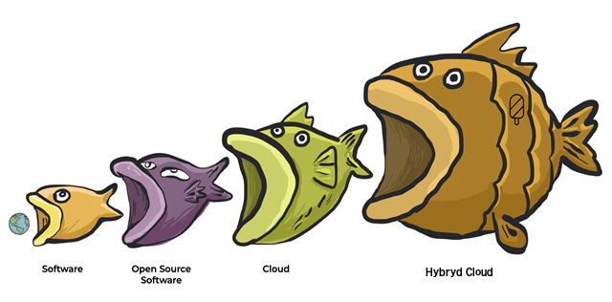
The argument is “open source eating cloud”. Admittedly, “eating” is not the most precise term, allowing different interpretations. Nevertheless, attempts to understand how exponents of open source doing the eating score this contest quickly get fuzzy and even metaphysical (“Sure, the clouds may take most of the revenue, but it is a moral victory for open source…”).
The public clouds are taking (dare we say “eating”?) open source software and operating that software as a service. One can say the public clouds are powered by open source (though they have plenty of proprietary software too), but that still seems like the clouds are the ones doing the consuming. From an economic perspective (which is what all the industry think pieces and analogies are about), the clouds seem to make a better business from open source than the companies built around particular projects. If you squint, open source could be seen as a very generous charitable donation to some of the largest and wealthiest corporations on the planet.
Our dining dichotomy stems from open source and clouds playing fundamentally different games. Open source enthusiasts and companies are focused on specific pieces of software and how that sausage gets made. The public clouds transcend software and operate on a vastly more expansive plane of existence where software is an important but not the sole ingredient of a service.
The public clouds knit together transoceanic cables, slabs of concrete, a reliable flow of electrons, millions of CPUs, exabytes of disk, software runtimes aplenty, legal standing and an army of people providing 24×7 operations and support, all integrated into a transactable utility accessible by anyone with a credit card. Software people often fail to appreciate that cloud services are so much more than just an instance of software, and operations is its own competency.
A big part of the value of cloud is independent of the underlying software: it lets customers get out of low value/high complexity operations (an attribute which applies equally to both open source and perniciously proprietary software). Open source software often skews to the complex, sometimes to the very complex (hello, Kubernetes!), making it all the more attractive to package and deliver as a service.
The unexpected and asymmetric competition from the clouds challenges open source companies, who must confront the fact the competitive advantage of knowing their software better than anyone else isn’t the insurmountable moat they had hoped.

It is never fun to wake up and discover your product is now just a feature of a broader offering, but this is what is happening with software. Claiming open source is eating the cloud is like coffee bean farmers claiming they’re eating Starbucks: it willfully ignores the vast majority of what the customer is buying.

The argument for open source winning our eating contest boils down to, “at the end of the day”, victory is inevitable, because of the freedom and flexibility of OSS. Privacy, compliance and plain customer service will push OSS to the pole position, with the Hybrid Cloud Solution.

Enter Vendor Lock-In, Privacy, Compliance And The Hybrid Cloud Solution

Great hybrid, local-first software should have seven key properties.

- It should be fast. We don’t want to make round-trips to a server to interact with the application. Operations can be handled by reading and writing to the local file system, with data synchronisation happening in the background.

- It should work across multiple devices. Local-first apps keep their data in local storage on each device, but the data is also synchronised across all the devices on which a user works.

- It should work without a network. This follows from reading and writing to the local file system, with data synchronisation happening in the background when a connection is available. That connection could be peer-to-peer across devices, and doesn’t have to be over the Internet.

- It should support collaboration. “In local-first apps, our ideal is to support real-time collaboration that is on par with the best cloud apps today, or better. Achieving this goal is one of the biggest challenges in realizing local-first software, but we believe it is possible.“

- It should support data access for all time. On one level you get this if you retain a copy of the original application (and an environment capable of executing it). Even better is if the local app using open / long lasting file formats. See e.g. the Library of Congress recommended archival formats.

- It should be secure and private by default. “Local-first apps can use end-to-end encryption so that any servers that store a copy of your files only hold encrypted data they cannot read.”

- It should give the user full ownership and control of their data. “…we mean ownership in the sense of user agency, autonomy, and control over data. You should be able to copy and modify data in any way, write down any thought, and no company should restrict what you are allowed to do.“

The Open-Source, Private Cloud Alternatives to Dropbox, Slack, Office 365

BA.net offers security-minded organizations storage and productivity options to run on private cloud, self-hosted, or hybrid servers.
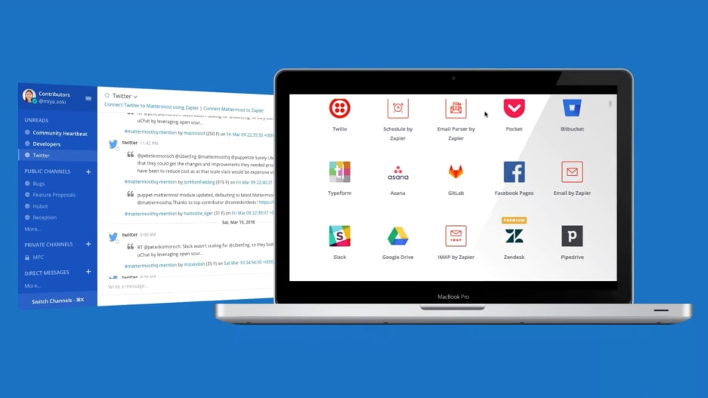
In a flash, much of our cyberlife—both private and professional—has moved to the cloud. Mega-tech companies hold the data crucial to millions: Our virtual offices chat via Slack, our kids’ pics clog Google Photos, and hundreds of millions share files large and small in Dropbox.
While the big guys will make the case that they are secure, some privacy-minded organizations are not so sure.
This was highlighted recently in Germany when government officials said they are moving away from third-party platforms for its 300,000 workers who collaborate over multiple devices. Instead, the federal IT agency will be using Nextcloud, an open-source, internally hosted tool produced by a German company of the same name.
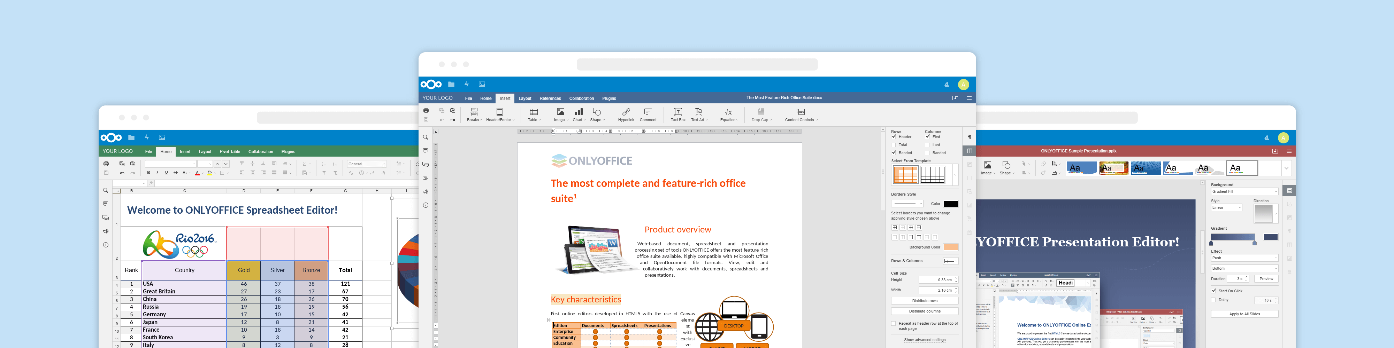

It is part of a growing trend to replace centrally hosted services with those that can be run on servers under an individual or organization’s control in their own legal jurisdictions and customized to their speciic needs.
“As a company, we don’t have any servers we don’t do any hosting” says Nextcloud founder and managing director Frank Karlitschek, speaking with Fast Company through his product’s video chat feature. “They put it on whatever hardware or hosting infrastructure they trust.”
For a family or couple looking to share files or photos or keep their calendars in sync, that can be something as simple as a self-hosted bootable image on an old laptop. In more ambitious scenarios, where the software is supporting hundreds of thousands of users chatting and collaborating on shared documents, it can be run in a modern data center on more sophisticated infrastructure, likely with a support contract from a provider like BA.net.
“If you have a bigger setup, you really want to have proper monitoring and proper backup and proper intrusion detection and so on,” Karlitschek says.
Karlitschek previously created ownCloud, a similar tool that’s still in active use and development. And Beijing-based Seafile says it has signed more than 20 major educational institutions around the world as paying customers for its own open-source, self-hosted file-sharing tool. It supports security features like end-to-end encryption, where files are encrypted before being uploaded to the server, something CTO and cofounder Jonathan Xu says is lacking in many competing products.
“Many home users use our community edition to host their own files, for replacing Dropbox etc.,” writes Xu in an email to Fast Company. “They appreciate the speed and reliability of Seafile.”
The move to the self-hosted cloud isn’t limited to file-sharing tools. Nextcloud Talk, a workplace chat tool with features similar to Slack, is designed to be hosted on a company’s private servers, storing chat logs in the company’s databases.
“The people that use Nextcloud Talk are going to be the ones that care the most about security,” says CEO Ian Tien. “We like to say, if you’re under regulation or under attack.”
Since it’s open source, it can also be customized to meet its users’ needs, and users have built and shared code to make it compatible with a variety of deployment tools and hosting infrastructure.
“You can make it work with basically anything because you have the source code,” says Tien.

Nextcloud Talk – Chat, Voice and Video Calling – First Impressions
Nextcloud Talk, world's first self-hosted, enterprise-ready, and end-to-end encrypted audio/video and chat communication platform.
Once upon a time, Skype was the voice and video calling platform for people. It was independent, decentralized and offered end-to-end encryption. But that was a long time ago, today it’s centralized, more closed source than ever, and encryption seems to be rather optional. But on PCs there was little else that was usable and universal, perhaps until now. A few days ago I started to test

Nextcloud Talk, that, despite its name is a full blown Chat, Voice and Video Conferencing and Calling Solution.
The Basics
When Nextcloud is already installed, ‘Talk’ can be installed with the click of a button and works out of the box without any additional configuration. Calling someone is as easy as selecting another user of my Nextcloud installation at home from a drop down list and by pressing the ‘Join Call’ in the web browser. The called user gets a notification message on the screen if Nextcloud is open in a browser tab or if they’ve installed the Nextcloud Talk Android or iOS app.
External Users, Voice, Video and Group Calling
It is also possible to invite somebody to a group voice and video call by generating a link in the ‘Talk’ app in Nextcloud in the browser and then send the link by any means, i.e. by eMail, messenger, etc. When the recipient clicks on the link a new web page is opened that leads to my Nextcloud instance from which the WebRTC based client is started in the recipient’s web browser. All very seamless, no software needs to be installed, the recipient just has to confirm that the web browser is allowed to use the microphone and camera.
While not a telephone replacement due to the missing alerting, which should not be too hard to implement on Android and perhaps also on iOS, it is still a great tool to make end-to-end encrypted voice and video calls. Also, all meta-data is exchanged via my Nextcloud instance, i.e. this information is also not stored somewhere else!
Over the past few months we have tested hundreds of calls, many with a duration of more than one hour. Voice and video quality was excellent, and video calls use around 2 Mbit/s of bandwidth in each direction. Audio-only calls just use a few kilobytes a second.
Direct Media Streaming
Voice and video calls are not limited to two people, it is also possible to establish audio and video conferences with several people. There is no central element, media is streamed peer to peer as I noticed when I took a closer look at Wireshark, even though both ends of the connection were behind a IPv4 NAT gateway or behind IPv6 firewalls that only allow outgoing connection establishments.
Not having a central distribution point also means that in a conference call, each client seems to send its voice and video channel separately to each party. In other words, you better have a fat uplink for larger conferences to keep up video quality.
Where to go from here?
Nextcloud Talk is a formidable replacement to Slack, Skype. The solution could very well replace a lot of ‘ordinary’ phone calls between road warriors. In addition to the superior voice quality, especially when roaming and HD-voice not being available, it’s the end-to-end encryption and metadata being only created on the Nextcloud server at the office that are the killer-features for me!
Once companies choose to adopt decentralized cloud tools, there’s still the question of where to host them. While many large organizations naturally install them in their own data centers, others choose to host them on cloud-based servers. The Amazon Web Services Marketplace even contains multiple ready-to-go server images preloaded with everything that’s needed to run Nextcloud.
Running high-level private cloud services on top of centralized cloud servers may not be the contradiction it seems. Many companies have come to trust cloud providers like AWS, Google Cloud Platform and Microsoft Azure to build stable and secure infrastructure, and without the right economies of scale, it can be difficult for self-managed servers to compete on price.
“It has to be very efficient in terms of manpower,” says Jean Atelsek, an analyst at 451 Research, to get prices below public cloud services when engineering and other costs are included. “At a typical utilization percentage, upwards of 600 virtual machines per engineer have to be managed in a private cloud.”
Some companies even choose to outsource managing decentralized cloud tools entirely. Karlitschek says they can still shop and potentially port data between multiple providers based on costs, service guarantees, and other factors.
“The main difference is there’s not only one service provider, but we have 100,” says Karlitschek. “You can pick and choose.”

What microsoft won’t tell you about office 365 subscriptions

Microsoft subscriptions are seriously confusing. So much so that in addition to Microsoft you generally have to pay a Gold reseller to manage the billing complexity. Which can include expensive surprise SAM and BSA audits and big fines.

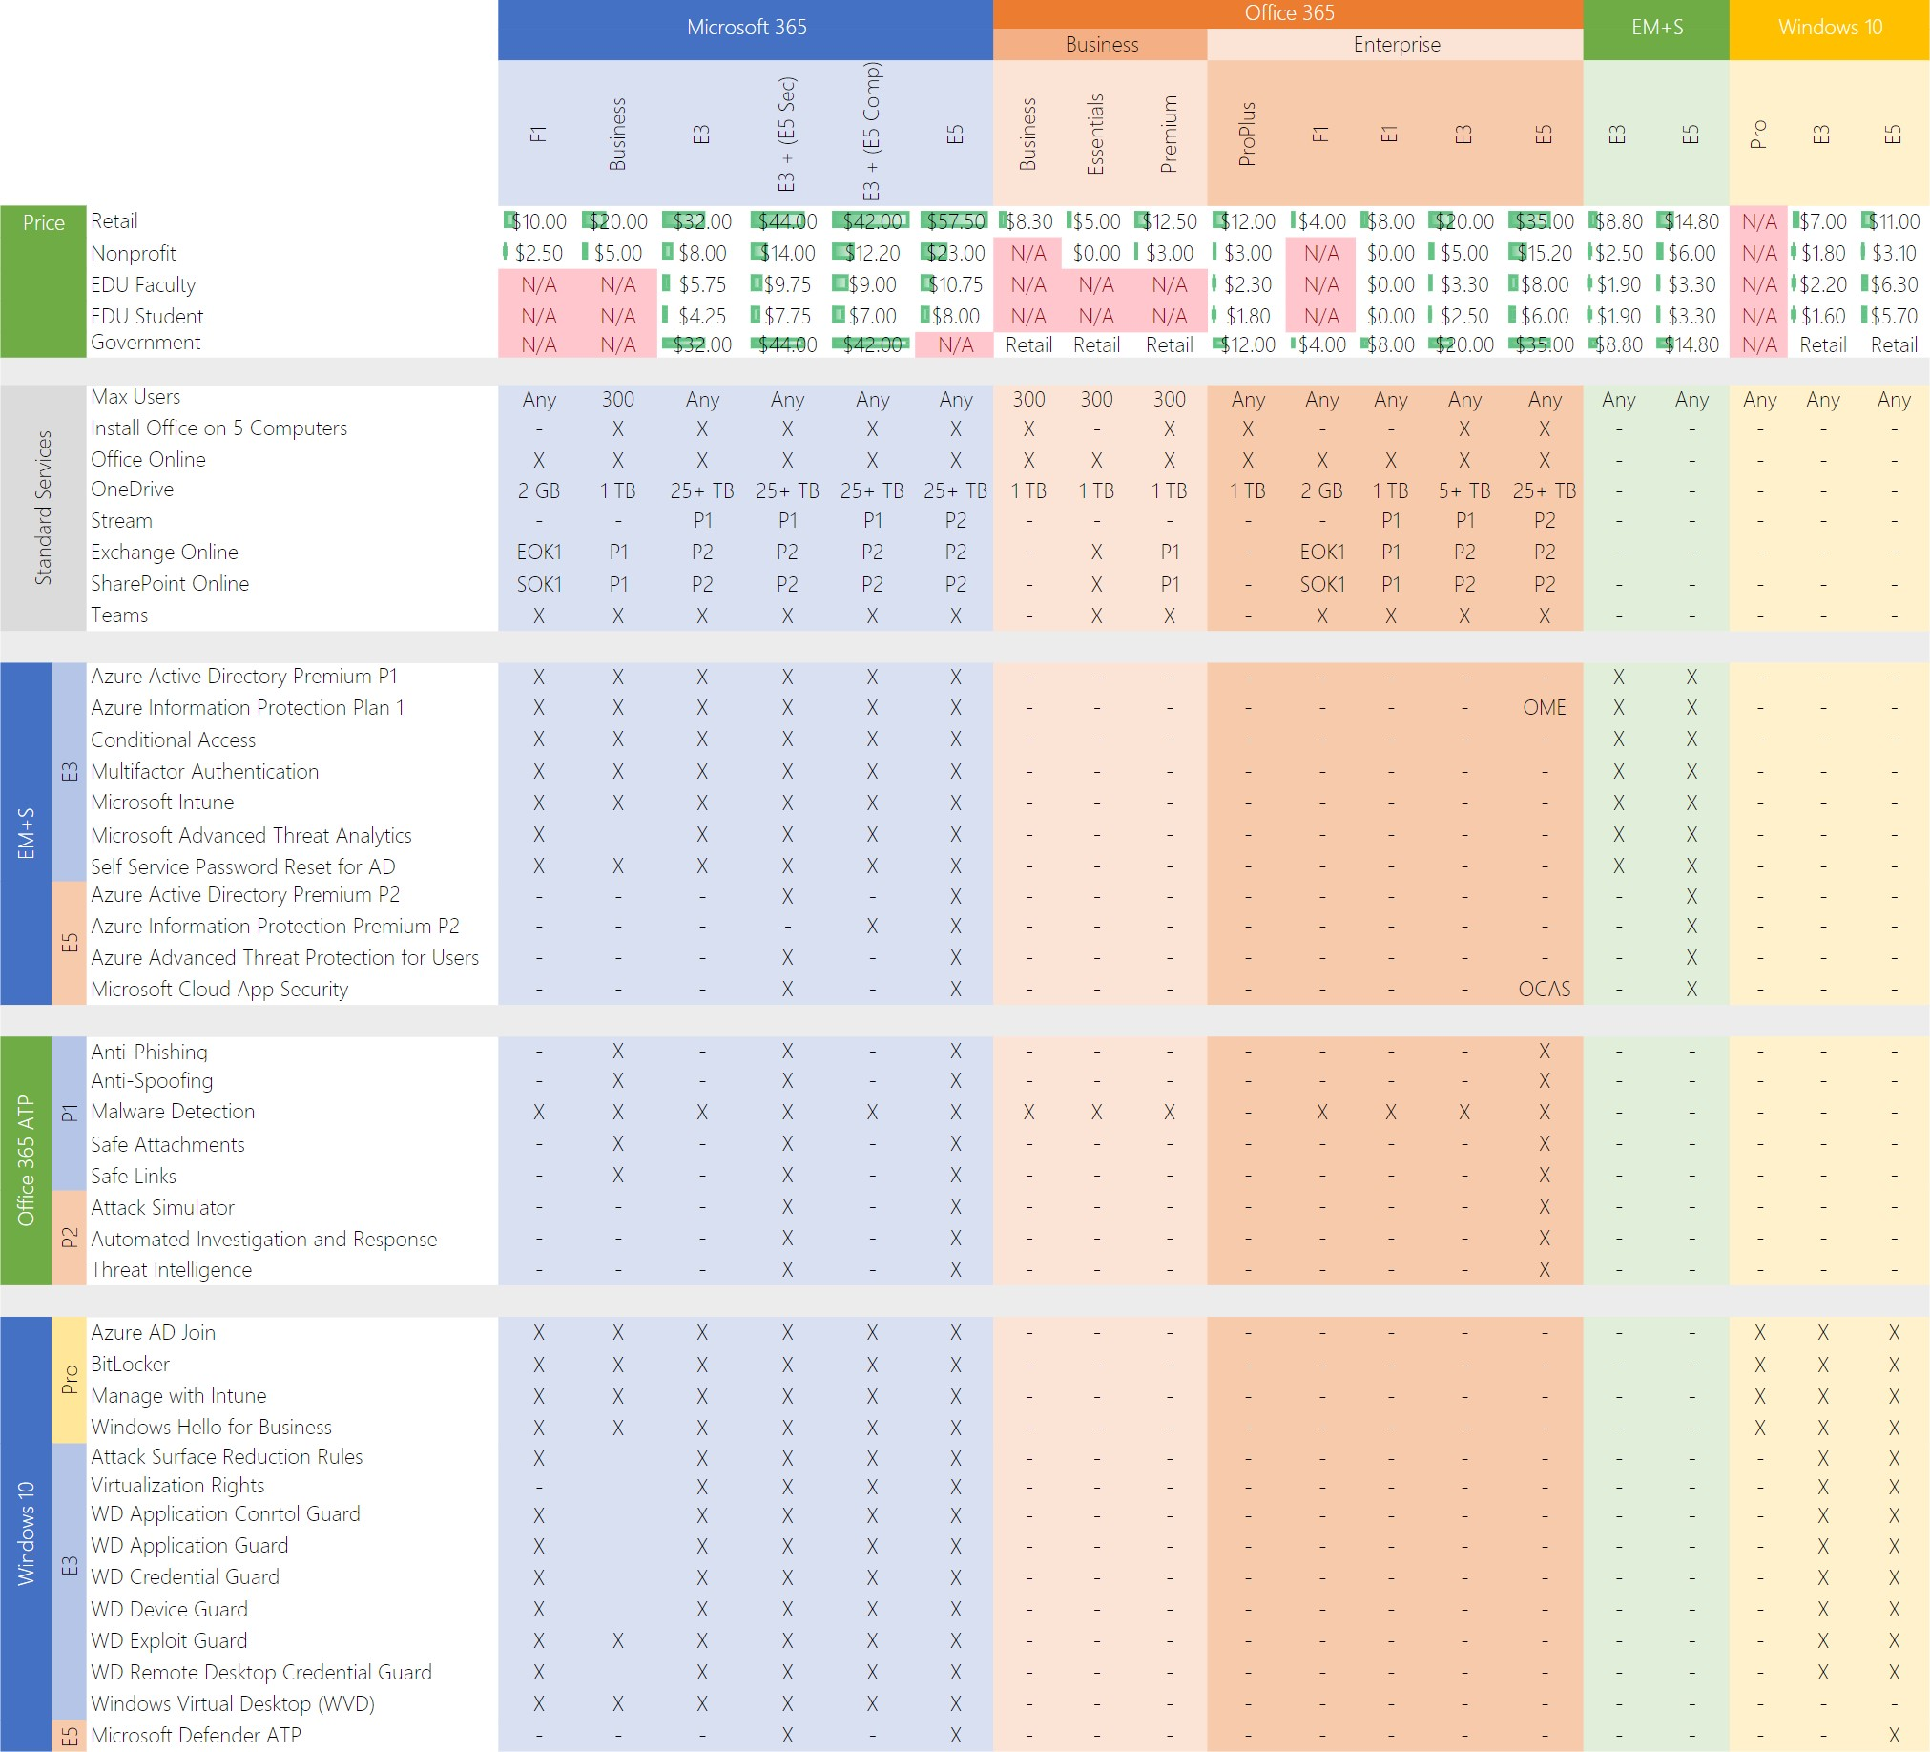

Factor in all the costs

The simplest calculation for an Office 365 migration doesn’t require a spreadsheet. Just count the number of seats and multiply by the cost of your enterprise plan. Typically between $9 and $50 per user, per month!

Chances are that number will seem high, perhaps as much as 30% higher than your corresponding budget for traditional server and desktop software licenses.

But the total cost becomes more reasonable when you factor in some of the cloud savings:
- Lower data center costs: You probably won’t be able to eliminate your server room completely, but you should be able to consolidate servers and cut your hardware budget.
- Reduced IT workload: Because Microsoft is managing Exchange, SharePoint, and other servers, IT admins don’t have to plan for downtime to install patches each month.
- Fewer help desk calls: Those self-service installations of Office apps on Windows, Mac, and mobile devices mean no lost product keys and no activation issues –both of which can cause serious support headaches and user angst.
- Of course these advantages are available with Private Cloud Office providers. With no lock-in, more flexibility and much lower prices.

BeyondCorp: How Google Dropped VPNs for Remote Employee Access
Open Source Software (OSS)
Freedom, flexibility, low cost, no vendor lock-in, no jumping through monopoly license hoops, enables byod, local software, hybrid cloud, retire old firewalls, new security model zero trust, corporate access proxy.
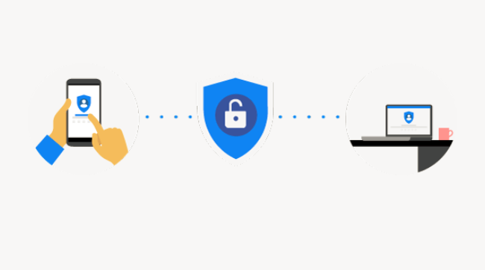
Today, none of Google’s employee-facing applications are on a virtual private network. They all have public IP addresses.
The company feels this approach, which it has dubbed BeyondCorp, is the “new cloud model,” for doing cloud security, asserted Neal Mueller, head of infrastructure product marketing at Google, who gave a presentation on this approach at the O’Reilly Security conference, held recently in New York.
This model can be fall under a number of rubrics in the security community, including “zero-trust” or “perimeter-less” security. It is the opposite of the traditional approach of security, which Mueller described as “the castle” approach, in which a strong firewall is used to set off an internal network that can only be accessed by way of a virtual private network (VPN).
The problem with the “castle” approach is that once the perimeter is breached, the entire internal network, and all the associated applications, are at risk. “Do not trust your network. It is probably already owned,” added Max Saltonstall, a Google program manager for corporate engineering, who also participated in the presentation. Phishing, man-in-the-middle, SQL Injection attacks all find fertile ground on VPNs.
Plus, a VPN was cumbersome to use, and slowed performance, especially for overseas workers. And it is no walk in the park for admins either. To set up a new user, the admin would typically have to configure the cloud network, along with setting up the IPSec rules and firewall rules, the VPN. This is followed by a lot of testing.
For cloud apps, Google ditched VPNs for zero-trust identity-aware proxy
At Google, “we embraced the fact that walls don’t work,” Mueller said. “Rather than have a VPN around all this infrastructure, we decided to get rid of the walls entirely.”
Google’s approach involves comprehensive inventory management, one that keeps track of who owns which machine in the network. A Device Inventory Service collects a variety of live information about each device from multiple system management sources, such as Active Directory or Puppet.
Authentication is then based on a set of “Trust Tiers” represent levels of increasing sensitivity. Employees get the appropriate level of access regardless of what device they are using or where in the world they are logging in from. Lower levels of access require less stringent checks on the device itself.
“The access is granted based on context: Who are you? Have you authenticated in a strong way? What are you using? What do I know about your device?” Saltonstall summarized.
The network itself is unprivileged. For identity management, the company uses security keys, which are much harder to forge than passwords and are tied to the individual users themselves. Each work device has a certificate issued by Google. Encryption across the network is done through TLS (transport layer security), which is terminated at the access proxy.
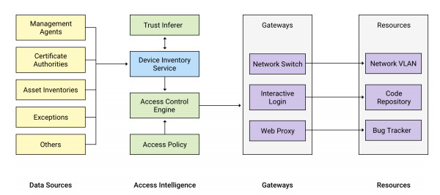
BeyondCorp infrastructure (USENIX)
All the corporate resources are behind this uber-reverse proxy. Based on a decision provided by its “trust engine,” the proxy makes the decision of whether or not to provide access to the desired application. If permissions are in place, according to the tiered trust model, it forwards the requests to the application, along with the security credentials. The applications themselves are routinely checked for breaches by vulnerability scanners.
Amazingly, Google was able to shift all of its employees, including remotes ones, over to this new model, with minimal disruption, Saltonstall said.
To prepare for a transparent shift, which started in 2013, the migration team recorded all the actions that Google employees did on the old network, then rerun a simulation of the traffic on the new network. This monitoring gathered about 80TB a day (The model benefited the fact that all of Google’s internal applications are already on the Web).
“If you play back the current traffic on the new network, you can see what will break,” Saltonstall said. This lets the team identify those end-services that weren’t fully compliant yet, as well as identified users who could seamlessly switch over to the new network.
This approach has some good additional benefits, Saltonstall said. Provisioning Chromebooks for new employees is a minimal processing, taking no longer than 90 seconds worth of configuration settings.
With the “BeyondCorp” approach, “You are taking operation problems, and turning them into engineering problems, and then engineer them away,” Saltonstall said. “All the frustrating, boring human grunt-work becomes automated.”

But the total cost becomes more reasonable when you factor in some of the cloud savings:

Lower data center costs: You probably won’t be able to eliminate your server room completely, but you should be able to consolidate servers and cut your hardware budget.
Reduced IT workload: Because Microsoft is managing Exchange, SharePoint, and other servers, IT admins don’t have to plan for downtime to install patches each month.
Fewer help desk calls: Those self-service installations of Office apps on Windows, Mac, and mobile devices mean no lost product keys and no activation issues –both of which can cause serious support headaches and user angst.
Of course these advantages are available with Private Cloud Office providers. With no lock-in, more flexibility and much lower prices.

How to Build a Remote Team: Resources and Advice From Remote Companies
More and more companies are hiring their first remote team members and leading remote companies are open and friendly about sharing their experiences with them. There are services available to help your company to start working remotely.

More and more companies are starting to realize the benefits remote work brings and are considering hiring their first remote team members.

A lot of companies are already working remotely from the office
Communication between team members is often already happening in a virtual office even if people are sitting in the physical office.
Sometimes team members might be sitting next to each other, but still communicate through text messages or on a chat channel so as not to disturb others workflow. This way they can work through the messages when they have the time.
If your company is already mostly communicating virtually, switching to remote can be quite easy. You just stop coming to the office!
This is exactly what Marketgoo did – they started building their do-it-yourself SEO tool in the office and have been gradually moving remote. First, the marketing manager and then the whole development team started working remotely. When there were no people left in the office, they did the only reasonable thing – closed the office for good!
“Co-working spaces, coffee shops (our biz dev guy is a regular at Tim Horton's!), working from the beach, home office, etc” answered Marketgoo’s marketing manager Larissa when I asked her about where their team mostly work from now that they don’t have an office anymore.
Marketgoo CEO shares some great feedback on how he feels about going fully remote:
“4 months after closing the office and I don't miss it at all! I am way more productive when working on the go. Before, I was tied to do big stuff only at the desk. I adapt much better now to any situation or venue. Only con is that I feel like a hermit sometimes”
Feeling like a hermit is quite common as loneliness has been reported as one of the biggest struggles that comes with remote work.

Advice from remote companies
Remote companies who are the frontrunners of the change to remote work are usually very open and friendly about sharing their experiences.
Some leading remote companies have shared their advice on RemoteHub for companies planning to start working remotely.

GitLab
The first single application for the entire DevOps lifecycle
GitLab, who is currently #1 most distributed team on RemoteHub with more than 250 cities across 51 countries and 60 time zones, says they have learned a lot about how to collaborate effectively and strengthen their culture while growing their remote team.

Doist

Building the future we want to work in
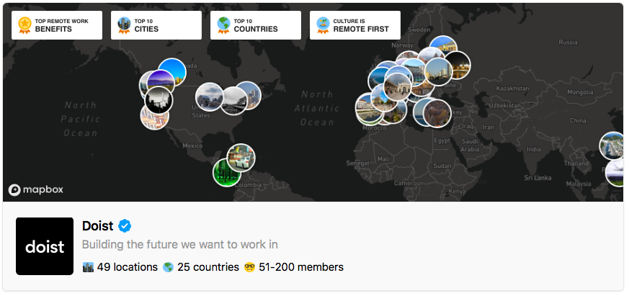
One of the leading remote companies Doist puts the emphasis on building a strong set of core values and uses them as a foundation to develop their remote culture.
They also recommend on choosing tools that will help your remote team stay connected and productive.
Doist is well-known in the remote circle by sharing their experiences as a team working remotely from 25 countries and building productivity tools like Todoist and Twist that are widely used by other remote companies.
As people are working from different places and often on different schedules, it’s even more important to be responsible for your work.

Teamweek
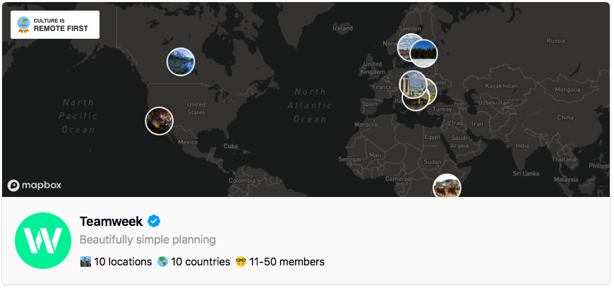
“First, we make sure people can and do take ownership of their work,” says Teamweek – a tool to plan your project timeline by a distributed company working across 10 countries.
They also emphasise the importance of honest communication and open discussions by expecting team members to share their plans, successes and failures, but they also keep the culture fun by sharing memes.

Services to help you build a remote team
As remote work becomes more and more popular, it is now possible to get some professional help to build a successful remote team.
Remote-how helps to get the most out of remote work by training the teams to work remotely. They’ve built a 6-week online program where industry-leading experts teach about how to build and lead effective distributed teams. There’s also a real live conference to help you build and scale a remote team.
If you’d like to meet some remote team leaders in person, there’s Running Remote conference that helps you to build and scale a remote team. The conference is packed with speakers from leading remote companies. They started the conference in “remote work paradise”, Bali in 2018 and their next conference is taking place in Austin, TX in the spring of 2019.

Start slowly
It probably might not be a good idea to close your office next Monday to have everyone working from wherever and see what happens. But if your company is working in a field where people are doing their most of their jobs on laptops and phones and you’re interested in flexibility and benefits remote work offers, you can gradually start converting your company to remote.
For a start, try to introduce a few days a week where your team works from home and gradually move to have more and more remote days over time.

